
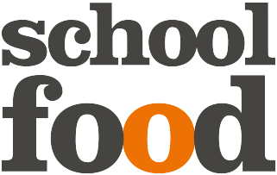


 | Monday | Tuesday | Wednesday | Thursday | Friday
Week Beg
8th
Mar
Week Beg
15th
Mar
Week
Beg

Week
Beg

Beefburger
Chips, Potato,
Sweetcorn

Tub of Ice-Cream
Fruit/Yoghurt

Savoury Mince
Mashed Potato
Carrots

Flakemeal Biscuit
Fruit/Yoghurt

Roast Pork &
Stuffing
Mashed Potato,
Broccoli, Gravy

Fruit/Yoghurt

Chicken Nuggets
Chips
Peas

Chocolate Fairycake
Fruit/Yoghurt

Fish Fingers
Mashed Potato
Beans

Date & Krispie Square
Fruit/Yoghurt

www.schoolfoodni.com

Lasagne
Chips, Potato,
Peas

Frozen Mousse
Fruit/Yoghurt

Sausages
Mashed Potato,
Carrots, Gravy

Orange Fairycake
Fruit/Yoghurt

School
Closed

School
Closed

Fish Cakes
Mashed Potato
Beans

Fruit/Yoghurt

Bread, Fresh Fruit, Yoghurt, Milk and Water are available daily

If you require any additional Information on allergens or Special diets please contact the school in the first instance

